Exercise section 13

Mehrab Atighi

11/18/2021

# Exercise section 13 part 1

library(psych)  
Data = data.frame(Kind = c(1,8,9,9,1,9,9) ,   
 Intelligent = c(5,9,8,9,9,7,7),  
 Happy = c(5,7,9,9,1,7,9) ,  
 Likeable = c(1,9,9,9,1,9,9) ,   
 Just = c(1,8,8,9,9,9,7))  
  
fa1 = fa(Data ,nfactors = 5 , rotate = "varimax")

## In smc, smcs < 0 were set to .0  
## In smc, smcs < 0 were set to .0  
## In smc, smcs < 0 were set to .0

## In factor.scores, the correlation matrix is singular, an approximation is used

fa2 = fa(Data ,nfactors = 5 )

## Loading required namespace: GPArotation

## In factor.scores, the correlation matrix is singular, an approximation is used

fa1$loadings  
## Loadings:  
## MR1 MR2 MR3 MR4 MR5   
## Kind 0.946 0.261 0.179   
## Intelligent 0.990 -0.109   
## Happy 0.980 -0.131   
## Likeable 0.940 0.285 0.129 0.125   
## Just 0.255 0.875 0.405   
##   
## MR1 MR2 MR3 MR4 MR5  
## SS loadings 2.807 1.902 0.234 0.037 0.000  
## Proportion Var 0.561 0.380 0.047 0.007 0.000  
## Cumulative Var 0.561 0.942 0.989 0.996 0.996

fa2$loadings

##   
## Loadings:  
## MR1 MR2 MR3 MR4 MR5   
## Kind 0.969 -0.231   
## Intelligent 0.519 0.806 0.276   
## Happy 0.784 -0.586 0.165   
## Likeable 0.970 -0.210   
## Just 0.703 0.666 -0.228   
##   
## MR1 MR2 MR3 MR4 MR5  
## SS loadings 3.258 1.533 0.163 0.026 0.000  
## Proportion Var 0.652 0.307 0.033 0.005 0.000  
## Cumulative Var 0.652 0.958 0.991 0.996 0.996

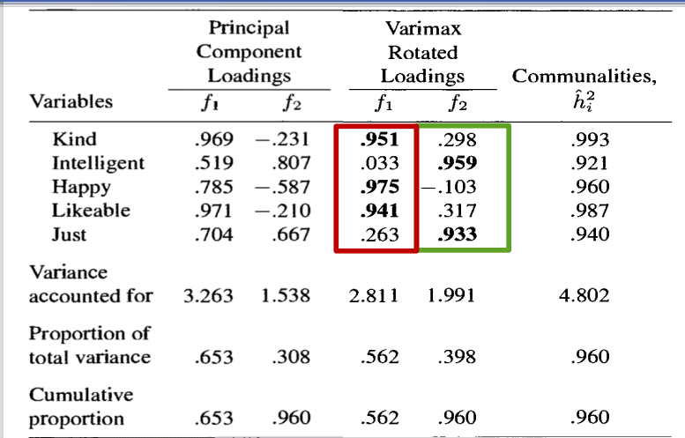

با توجه به تصویر میبینیم که مقادیر ضرایبی که برای دو عاملی که داریم بدست آمده است، دقیقا مشابه خروجی کتاب می‌باشد.و اندک تغییری هم که دارد برای رند شدن مقادیر هست.

# Exercise section 13 part 2

Country<-c("Belgium","Denmark","France","Germany","Greece","Ireland","Italy","Luxembourg","Netherlands","Portugal","Spain","United  
Kingdom","Austria","Finlad","Iceland","Norway","Sweden","Swirzerland","Albania","Bulgaria","Czech/Slovak","Hungary","Poland","Roma  
nia","USSR(Former)","Youslavia(Former)","Cyprus","Gilbralter","Malta","Turkey")  
Group<-c(rep("EU",12),rep("EFTA",6),rep("Eastern",8),rep("Other",4))  
AGR<-  
c(2.6,5.6,5.1,3.2,22.2,13.8,8.4,3.3,4.2,11.5,9.9,2.2,7.4,8.5,10.5,5.8,3.2,5.6,55.5,19.0,12.8,15.3,23.6,22.0,18.5,5.0,13.5,0.0,2.6,  
 44.8)  
MIN<-c(0.2,0.1,0.3,0.7,0.5,0.6,1.1,0.1,0.1,0.5,0.5,0.7,0.3,0.2,0.0,1.1,0.3,0.0,19.4,0.0,37.3,28.9,3.9,2.6,0.0,2.2,0.3,0.0,0.6,0.9)  
MAN<-  
c(20.8,20.4,20.2,24.8,19.2,19.8,21.9,19.6,19.2,23.6,21.1,21.3,26.9,19.3,18.7,14.6,19.0,24.7,0.0,35.0,0.0,0.0,24.1,37.9,28.8,38.7,19.0,6.8,27.9,15.3)  
PS<-c(0.8,0.7,0.9,1.0,1.0,1.2,0.0,0.7,0.7,0.7,0.6,1.2,1.2,1.2,0.9,1.1,0.8,0.0,0.0,0.0,0.0,0.0,0.9,2.0,0.0,2.2,0.5,2.0,1.5,0.2)  
CON<-c(6.3,6.4,7.1,9.4,6.8,7.1,9.1,9.9,0.6,8.2,9.5,7.0,8.5,6.8,10.0,6.5,6.4,9.2,3.4,6.7,8.4,6.4,6.3,5.8,10.2,8.1,9.1,16.9,4.6,5.2)  
SER<-  
c(16.9,14.5,16.7,17.2,18.2,17.8,21.6,21.2,18.5,19.8,20.1,20.2,19.1,14.6,14.5,17.6,14.2,20.5,3.3,9.4,10.2,13.3,10.3,6.9,7.9,13.8,23.7,24.5,10.2,12.4)  
FIN<-  
c(8.7,9.1,10.2,9.6,5.3,8.4,4.6,8.7,11.5,6.3,5.9,12.4,6.7,8.6,8.0,7.6,9.4,107,15.3,1.5,1.6,0.0,1.3,0.6,0.6,3.1,6.7,108,3.9,2.4)  
SPS<-  
c(36.9,36.3,33.1,28.4,19.8,25.5,28.0,29.6,38.3,24.6,26.7,28.4,23.3,33.2,30.7,37.5,39.5,23.1,0.0,20.9,22.9,27.3,24.5,15.3,25.6,19.1,21.2,34.0,41.6,14.5)  
TC<-c(6.8,7.0,6.4,5.6,6.9,5.8,5.3,6.8,6.8,4.8,5.8,6.5,6.4,7.5,6.7,8.1,7.2,6.2,3.0,7.5,6.9,8.8,5.2,6.8,8.4,7.8,6.0,5.0,7.2,4.4)  
Data<-data.frame(Country,Group,AGR,MIN,MAN,PS,CON,SER,FIN,SPS,TC)  
head(Data ,4)

## Country Group AGR MIN MAN PS CON SER FIN SPS TC  
## 1 Belgium EU 2.6 0.2 20.8 0.8 6.3 16.9 8.7 36.9 6.8  
## 2 Denmark EU 5.6 0.1 20.4 0.7 6.4 14.5 9.1 36.3 7.0  
## 3 France EU 5.1 0.3 20.2 0.9 7.1 16.7 10.2 33.1 6.4  
## 4 Germany EU 3.2 0.7 24.8 1.0 9.4 17.2 9.6 28.4 5.6

fa3=fa(Data[,-c(1,2)] , nfactors =9 , rotate = "varimax")  
fa4 = fa(Data[,-c(1,2)] ,nfactors = 9 )

## Loading required namespace: GPArotation

fa3$loadings

##   
## Loadings:  
## MR1 MR2 MR7 MR5 MR3 MR6 MR8 MR4 MR9   
## AGR -0.802 -0.265 -0.182 -0.390 -0.307   
## MIN -0.390 -0.217 -0.845 -0.255   
## MAN -0.121 0.882 0.319 0.290   
## PS 0.158 0.111 0.197 0.155 0.579   
## CON 0.714 0.230 0.117 0.118 0.151   
## SER 0.200 0.375 0.876 0.203   
## FIN 0.749 -0.117 0.105 -0.151 -0.138   
## SPS 0.924 -0.138 0.149 0.260 0.124 -0.131   
## TC 0.665 -0.158 0.229 -0.118 -0.162 0.358   
##   
## MR1 MR2 MR7 MR5 MR3 MR6 MR8 MR4 MR9  
## SS loadings 2.018 1.340 1.090 1.071 0.984 0.612 0.188 0.044 0.000  
## Proportion Var 0.224 0.149 0.121 0.119 0.109 0.068 0.021 0.005 0.000  
## Cumulative Var 0.224 0.373 0.494 0.613 0.723 0.790 0.811 0.816 0.816

fa4$loadings

##   
## Loadings:  
## MR1 MR2 MR3 MR4 MR5 MR6 MR7 MR8 MR9   
## AGR -0.913 -0.346 -0.129 0.102   
## MIN -0.653 0.262 0.609 0.294 0.127 -0.130   
## MAN 0.422 -0.695 -0.493 0.216 0.130 -0.123   
## PS 0.451 -0.172 -0.184 0.173 -0.155 -0.326   
## CON 0.404 0.507 -0.146 0.376 0.136   
## SER 0.702 0.531 -0.102 -0.259 0.374   
## FIN 0.304 0.604 -0.197 0.205 -0.260 0.114 -0.122   
## SPS 0.752 -0.110 0.523 -0.272 -0.255   
## TC 0.324 -0.440 0.526 0.238 0.111 0.168   
##   
## MR1 MR2 MR3 MR4 MR5 MR6 MR7 MR8 MR9  
## SS loadings 3.062 1.691 1.388 0.561 0.347 0.188 0.085 0.024 0.000  
## Proportion Var 0.340 0.188 0.154 0.062 0.039 0.021 0.009 0.003 0.000  
## Cumulative Var 0.340 0.528 0.682 0.745 0.783 0.804 0.814 0.816 0.816

با توجه به مشاهدات در بالا و دو روشی که بکار بردیم اگر ما از روش واریمکس هم برای دوران استفاده بکنیم، 6 تا عامل نیاز داریم تا بتوانیم 80% از واریانس کل را پوشش بدهد.